**Creation of Business Rules**

|  |  |
| --- | --- |
| Team Id | LTVIP2025TMID29041 |
| Project Name | Calculating family expenses |
| college | Kandula Lakshumma Memorial College of Engineering for Women |
| course | Computer Science  Engineering |

**Creation of Business Rules**

Automate backend logic and enforce business processes by executing Custom scripts when records are created, updated, deleted, or queried ensuring data consistency, validation, and process automation.

1. Go to All >> In the filter search for Business Rules.
2. Under System Definition Select Business Rules then click on New.

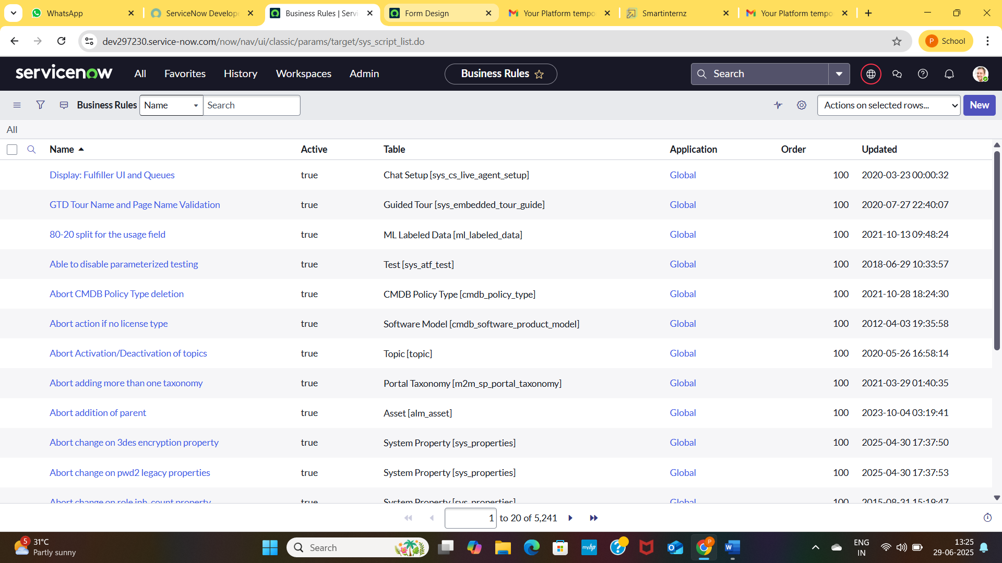

1. Enter the Details:

Name : Family Expenses BR

Table : Select Daily Expenses

Check Advanced

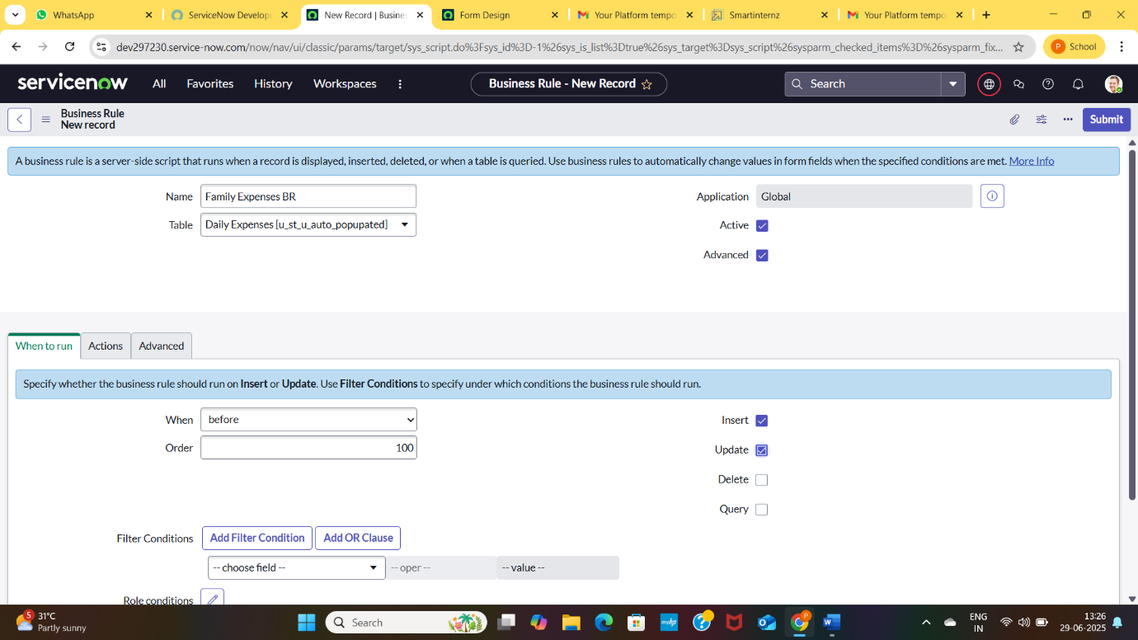

1. In Advance(we write the code): Write the below code >>

(function executeRule(current, previous /*null when async*/) {

var FamilyExpenses = new GlideRecord('u_family_expenses');

FamilyExpenses.addQuery('u_date',current.u_date);

FamilyExpenses.query();

if(FamilyExpenses.next())

{

FamilyExpenses.u_amount += current.u_expense;

FamilyExpenses.u_expense_details += ">"+current.u_comments+":"+"Rs."+current.u_expense+"/-";

FamilyExpenses.update();

}

else

{

var NewFamilyExpenses = new GlideRecord('u_family_expenses');

NewFamilyExpenses.u_date = current.u_date;

NewFamilyExpenses.u_amount = current.u_expense;

NewFamilyExpenses.u_expense_details += ">"+current.u_comments+":"+"Rs."+current.u_expense+"/-";

NewFamilyExpenses.insert();

}

})(current, previous);

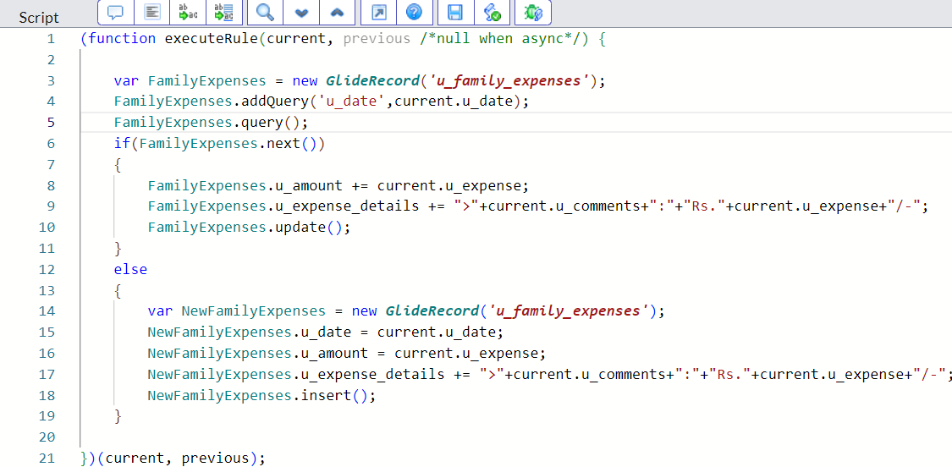

1. Go to the Header and right click there>click on save